**Tailored Application Access for Enhanced User Experience**

# 1. Project Overview

This project is focused on Tailored Application Access for Enhanced User Experience, designed to address Complexity in Personalization, Data Security and Privacy, Scalability Issues, Consistency, User Expectations and Usability, Integration with Legacy Systems, User Training and Support. The goal is to deliver a comprehensive solution by leveraging Advanced Technologies, Data-Driven Insights, Scalable Infrastructure , user centric design etc,.. Through this project, we aim to enhance [key benefit: e.g., operational efficiency, user experience, data accuracy] and support the long-term goals of business.

# 2. Objectives

**Business Goals**:

The business goals for Tailored Application Access for Enhanced User Experience focus on improving user satisfaction, increasing security, and boosting operational efficiency. Key objectives include personalizing user access to increase engagement and retention, enhancing security with role-based controls, and streamlining onboarding and support. Additionally, businesses aim to drive revenue by offering tailored features for different customer segments, improving cross-platform consistency, and supporting scalability as user bases grow. By aligning access control with user needs, organizations can reduce operational overhead, increase product adoption, and ensure compliance with regulatory standards, ultimately fostering customer loyalty and driving business growth.

**Specific Outcomes**: Key deliverables for **Tailored Application Access for Enhanced User Experience** include personalized user access through role-based controls, adaptive interfaces, and custom workflows. Streamlined onboarding processes tailored to user roles ensure faster ramp-up times, while robust security measures like multi-factor authentication (MFA) and role-based access control (RBAC) enhance data protection and compliance. Outcomes include a 20% increase in user retention, faster onboarding, and improved security compliance (e.g., GDPR, HIPAA). Cross-platform consistency ensures a seamless user experience across devices, boosting engagement by 25%. Scalable user management infrastructure reduces administrative overhead by 50%, enabling effortless expansion. Tailored self-service options, such as personalized FAQs and knowledge bases, lead to a 20% decrease in support queries. Analytics and reporting tools provide actionable insights into user behavior, driving continuous improvement and a 15% increase in feature adoption. Collectively, these deliverables enhance user satisfaction, streamline operations, improve security, and support business growth.

**3. Key Features and Concepts Utilized**

**Key Features of Tailored Application Access for Enhanced User Experience:**

1. **Role-Based Access Control (RBAC)**: Customizes access based on user roles, ensuring security and simplifying the interface.
2. **Personalized User Interface (UI)**: Adapts the interface dynamically to show relevant features and data, reducing cognitive load.
3. **Single Sign-On (SSO) & Multi-Factor Authentication (MFA)**: Simplifies secure access with SSO while enhancing security through MFA.
4. **Adaptive Onboarding**: Tailors the onboarding experience based on user roles or experience levels for faster, more engaging setup.
5. **Cross-Platform Consistency**: Delivers a consistent user experience across multiple devices (web, mobile, desktop).
6. **Data-Driven Analytics and Insights**: Provides real-time reports on user behavior, feature usage, and access patterns to inform improvements.

**Concepts Utilized**:

1. Role-Based Access Control (RBAC)-Concept: ServiceNow leverages RBAC to restrict or grant access to applications, data, and features based on user roles. This ensures that users only have access to the information and functions they need, enhancing security and user experience.
2. Dynamic UI and Personalized Dashboards-Concept: ServiceNow allows customization of the user interface to display role-specific dashboards, widgets, and tools. This enables a tailored user experience by showing only relevant information based on user roles or preferences.
3. Single Sign-On (SSO) Integration-Concept: ServiceNow supports SSO to streamline the login process, allowing users to access the platform seamlessly across different systems with one set of credentials. This improves security and user convenience.
4. Multi-Factor Authentication (MFA)-Concept: To enhance security, ServiceNow integrates MFA, requiring users to provide additional authentication factors, such as a code sent to their phone, alongside their username and password.
5. Self-Service and Knowledge Management-Concept: ServiceNow’s self-service capabilities, including knowledge bases and community forums, allow users to access relevant help and support resources. The platform personalizes these resources based on the user’s role or previous interactions.

# 4. Detailed Steps to Solution Design

**Activity-1**

1. Open service now developer Instance
2. Click on All
3. Search for Tables.
4. Under System Definition select Tables.

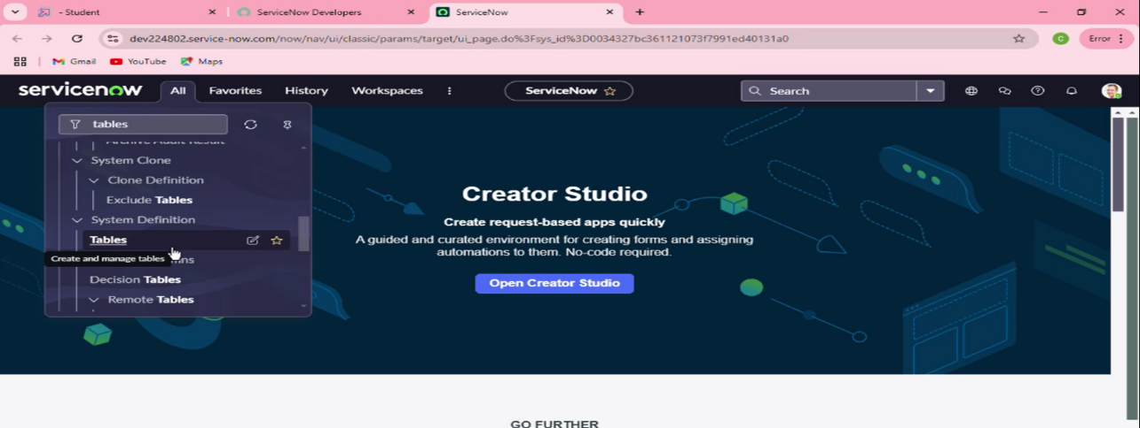

1. Then click on New.

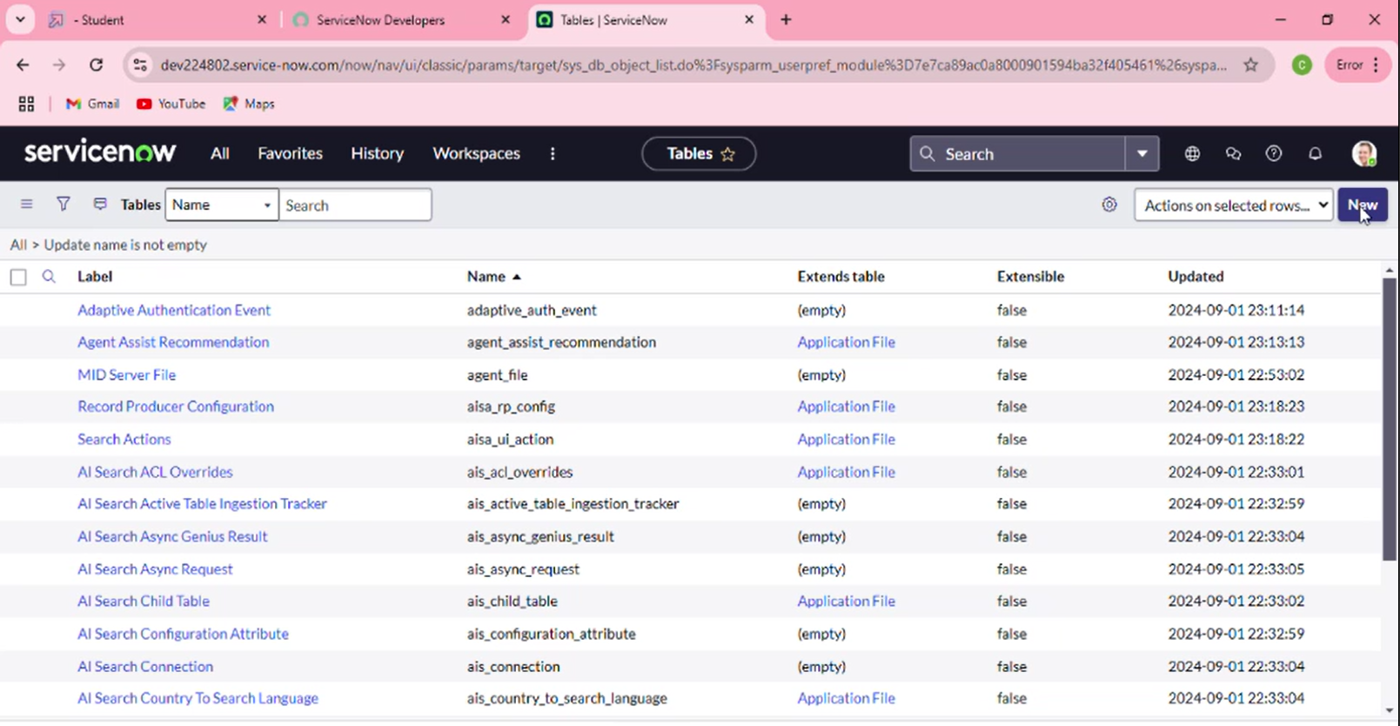

1. Fill the Details as:

Label : Service Request

Name : Auto-Populated

Add module to menu : Select Create New

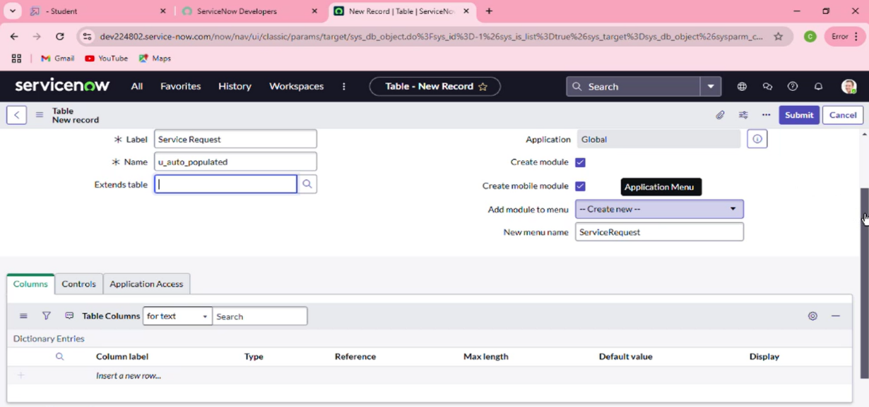Leave everything as Default.

1. Under Columns : click on insert a new row.

Column label : Name >> Type : String

Column label : Issue >> Type : String

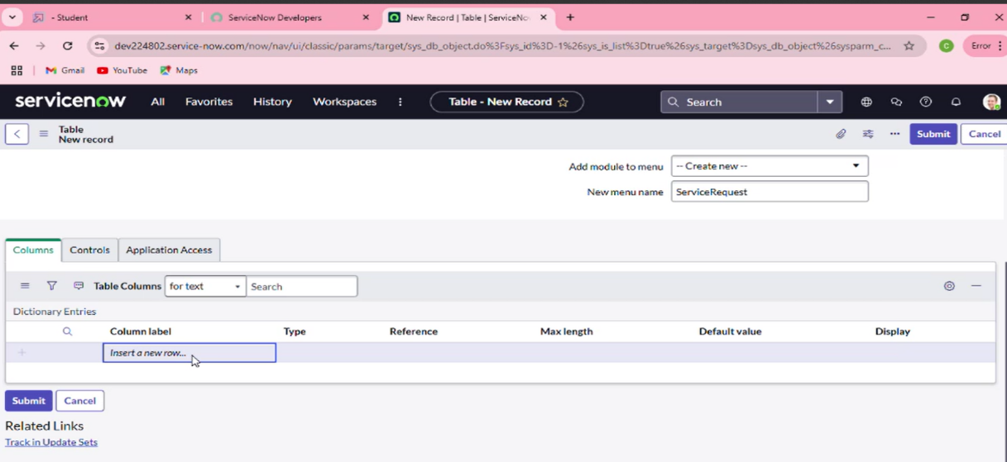

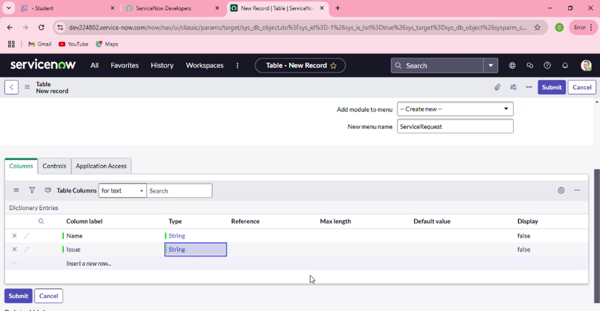

1. Click on Submit.

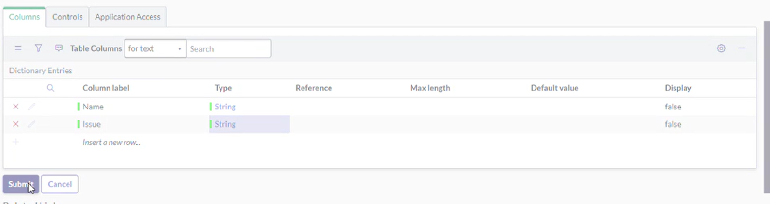

**Activity - 2: Create Users**

1. Open service now.
2. Click on All  >> search for users
3. 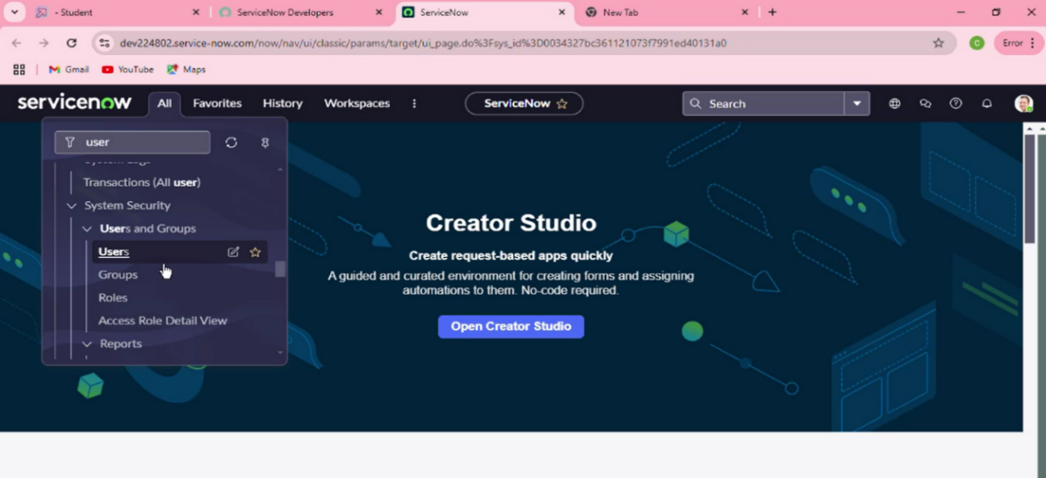Select Users under system security Click on new
4. Click on new

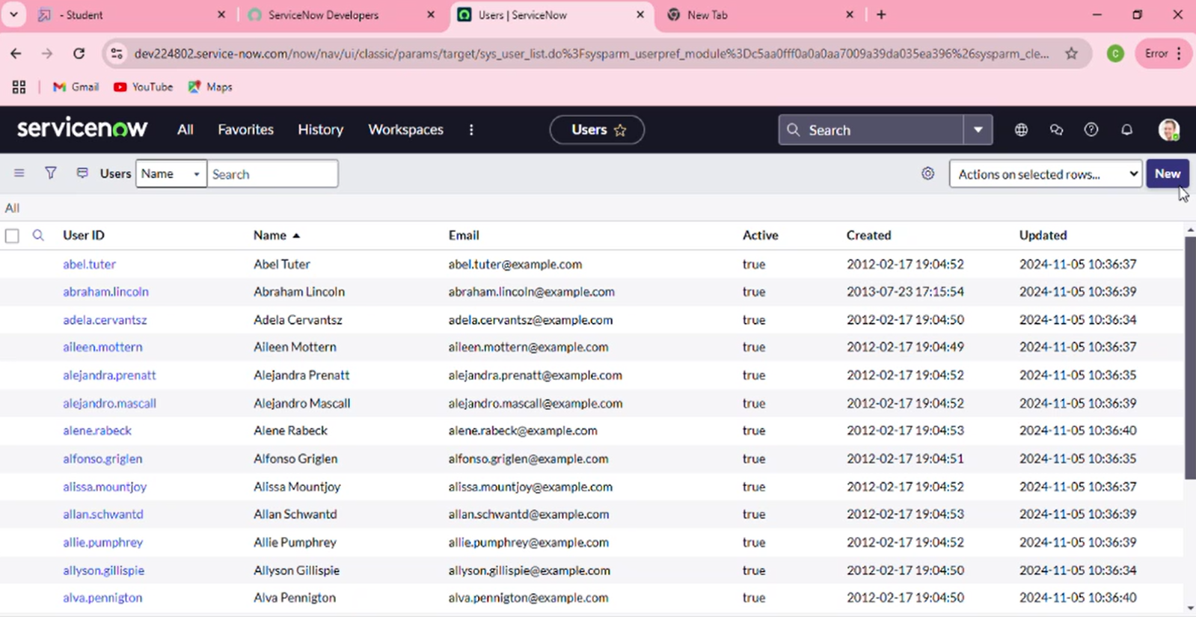

1. Filling the details.

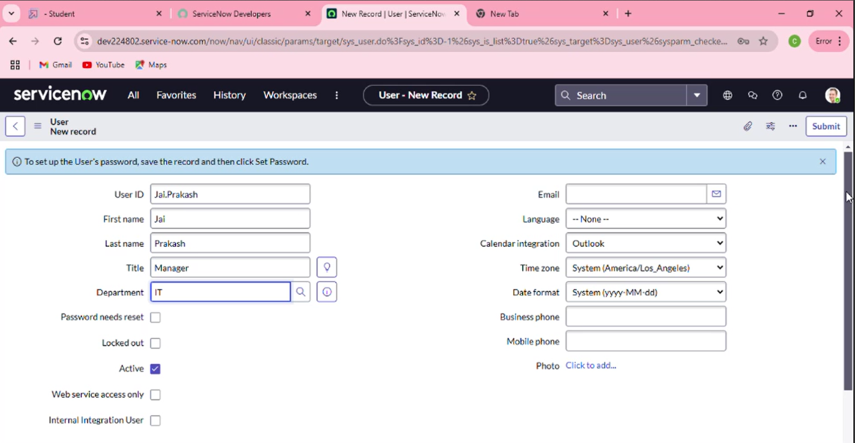

1. Click on Submit.

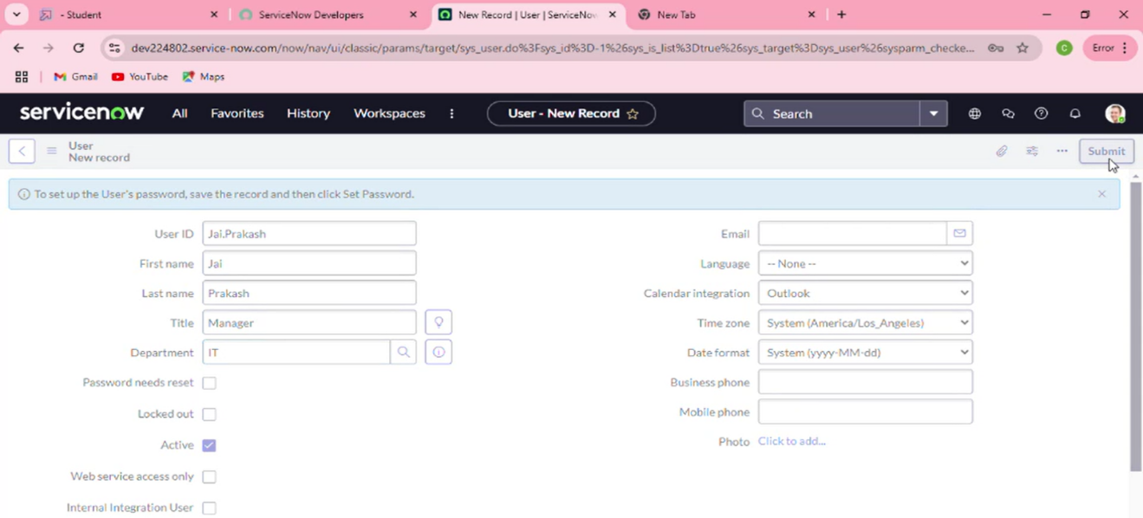

**Activity - 3: Create Groups**

1. Open service now.
2. Click on All  >> search for groups
3. Select groups under system security

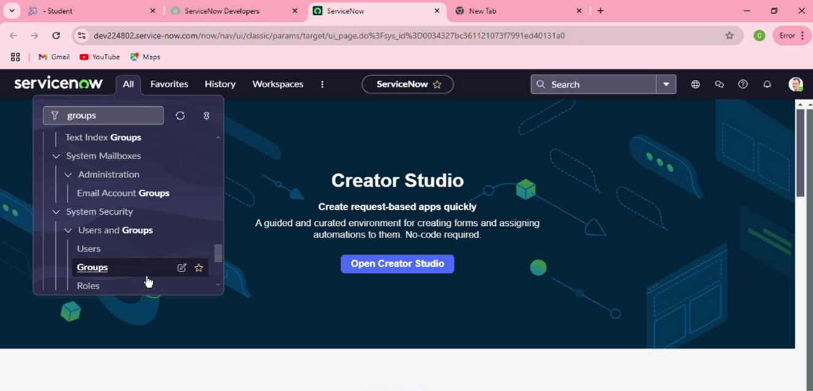

1. Click on new

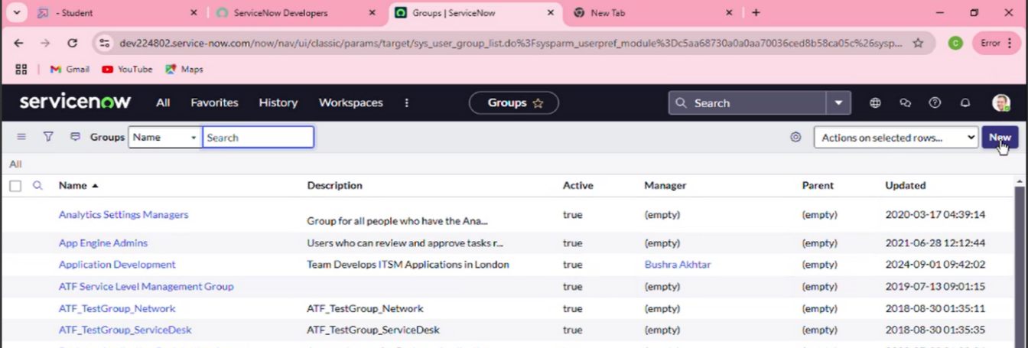

1. 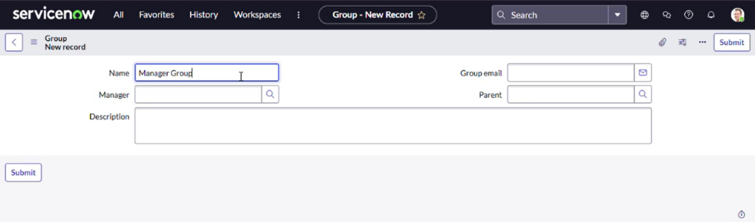Fill the following details to create a new group.
2. Under Group Members, click on edit.

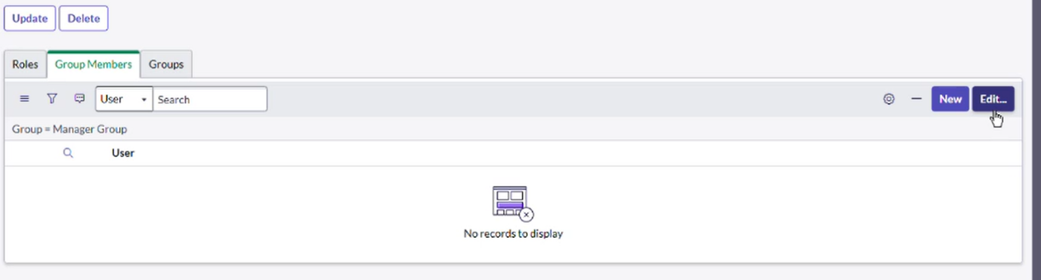

1. Add the user(Jai Prakash) to the Manager Group and click on Save.

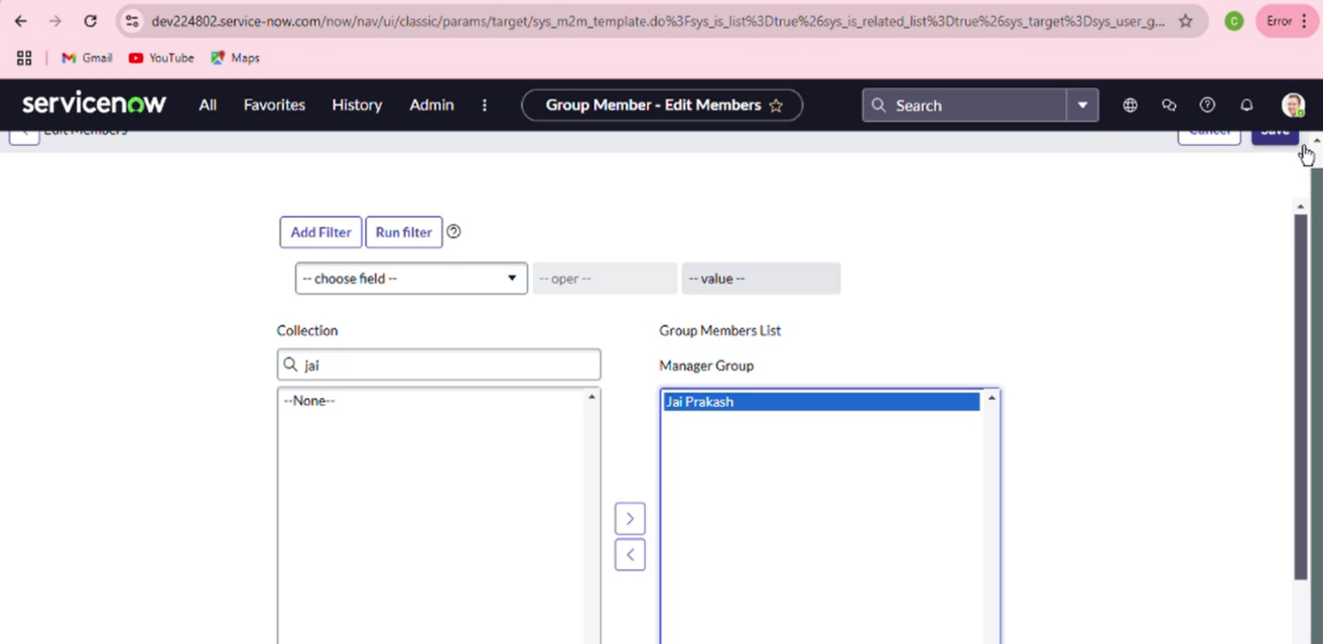

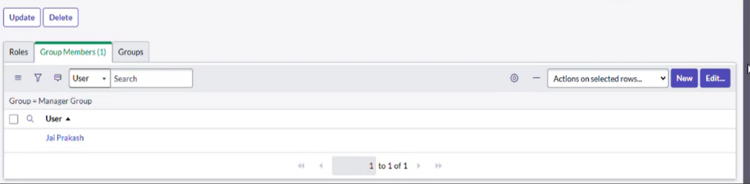

# Activity - 5: Creation of Modules

# Click on All.

# Search for Application Menus.

# Open Application Menus.

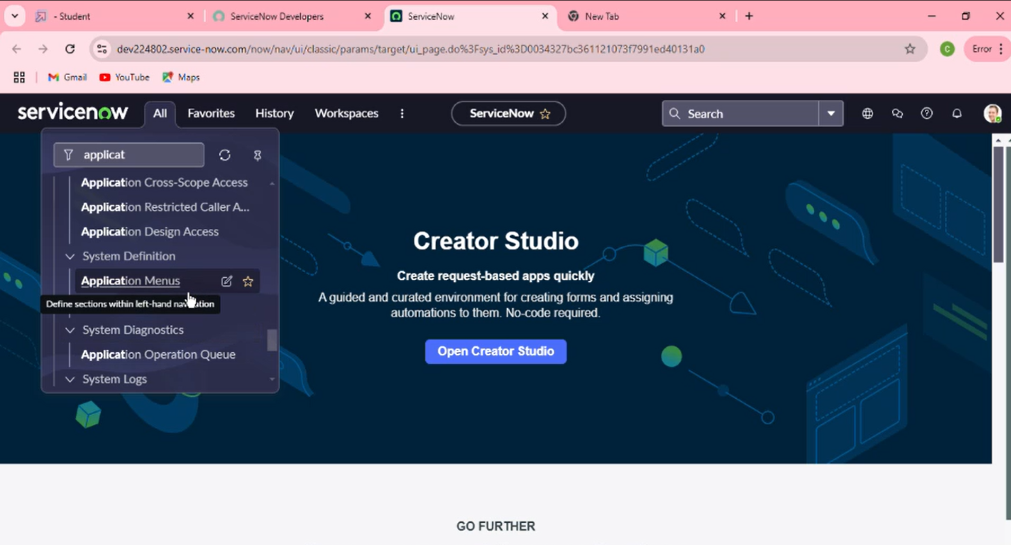

10. Under Title search for Service Request and open service request.

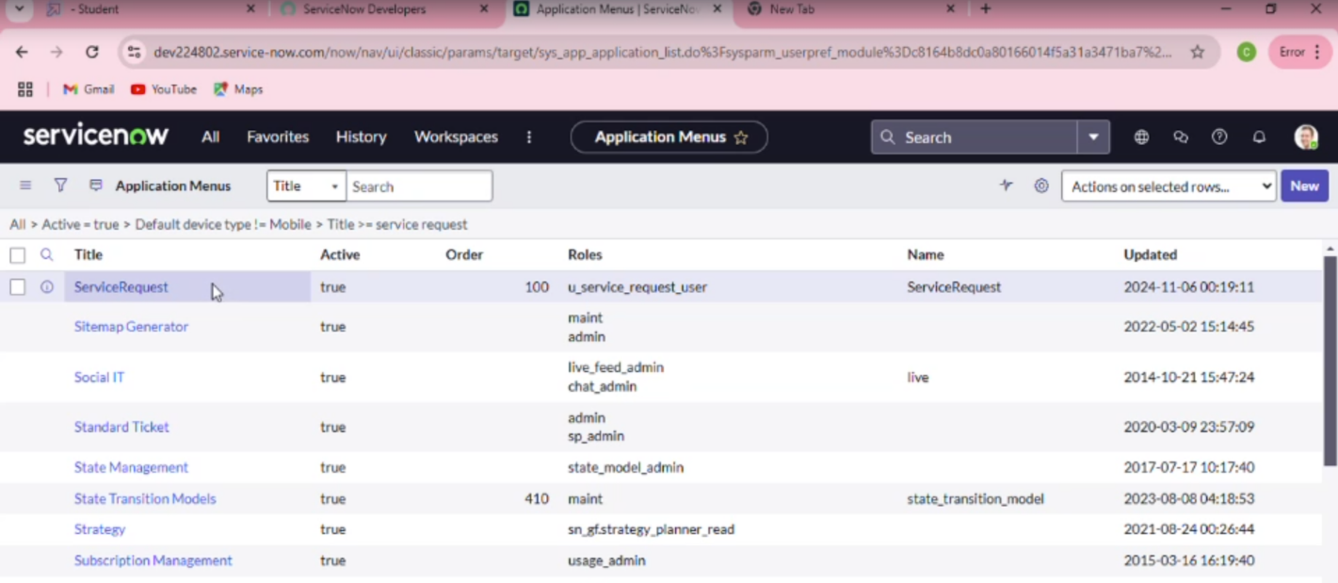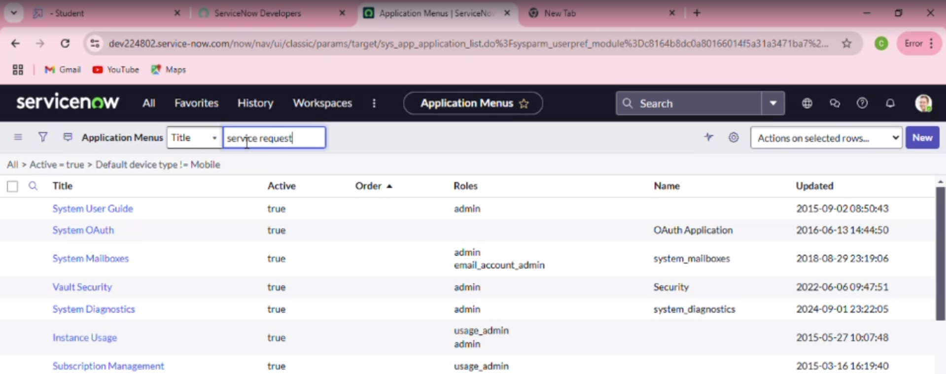

11. Under Roles, click on roles and Select the Role to which this should be viewed.

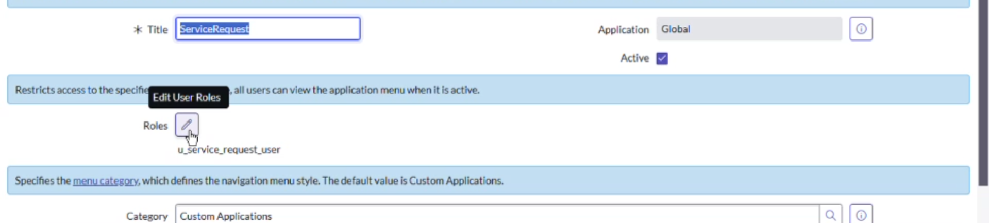

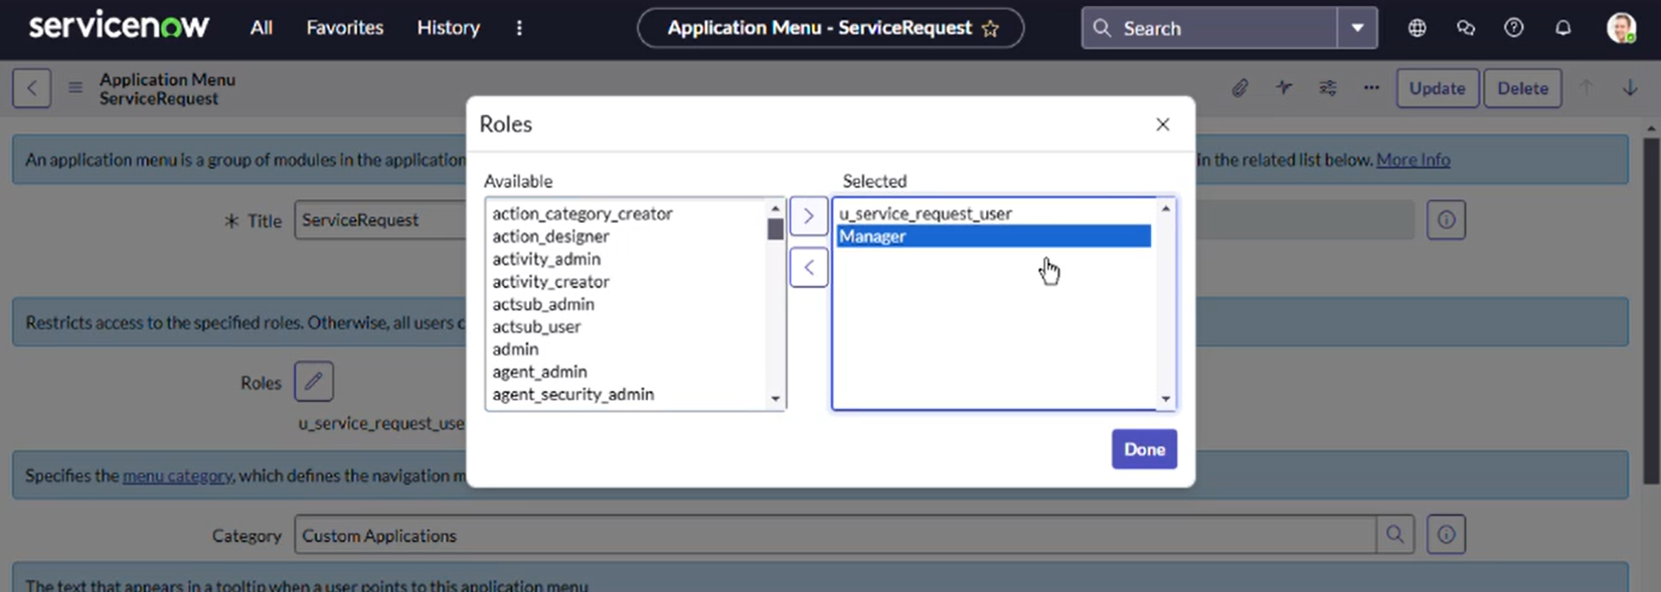

1. 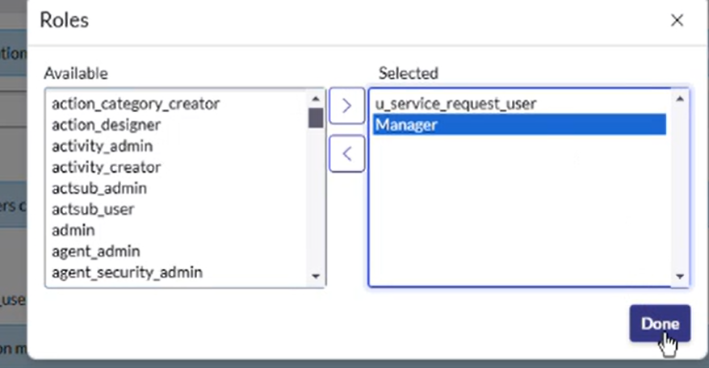Click on Done.
2. Now under Modules. Click on New.

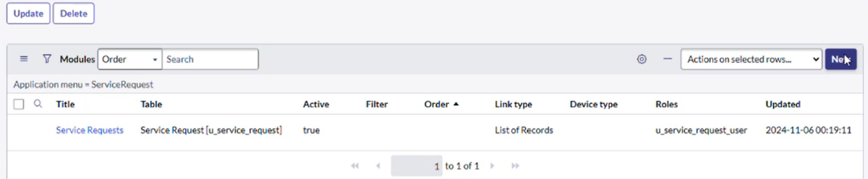

1. Enter the details as: Title : Create New.

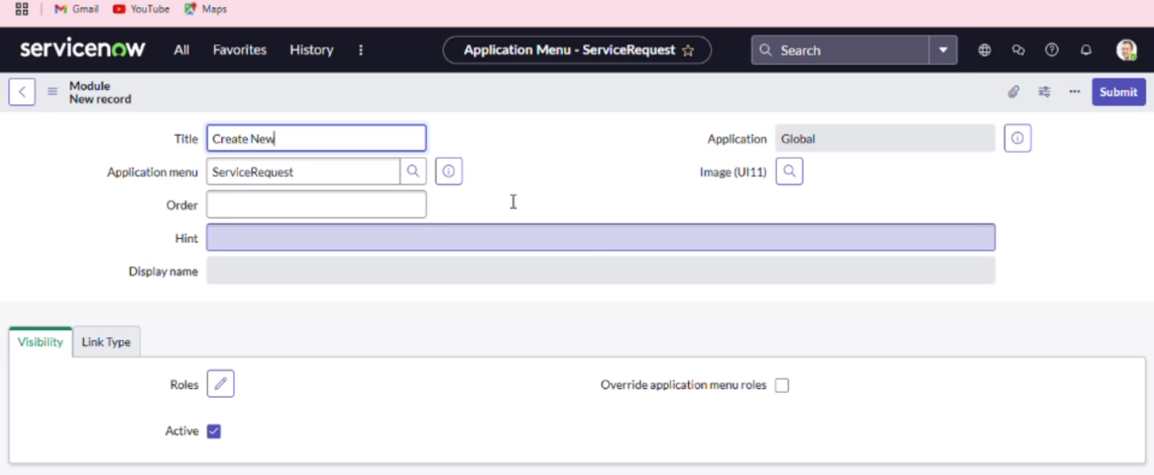

1. Under Visibility >> Select roles and select the role you want to assign.

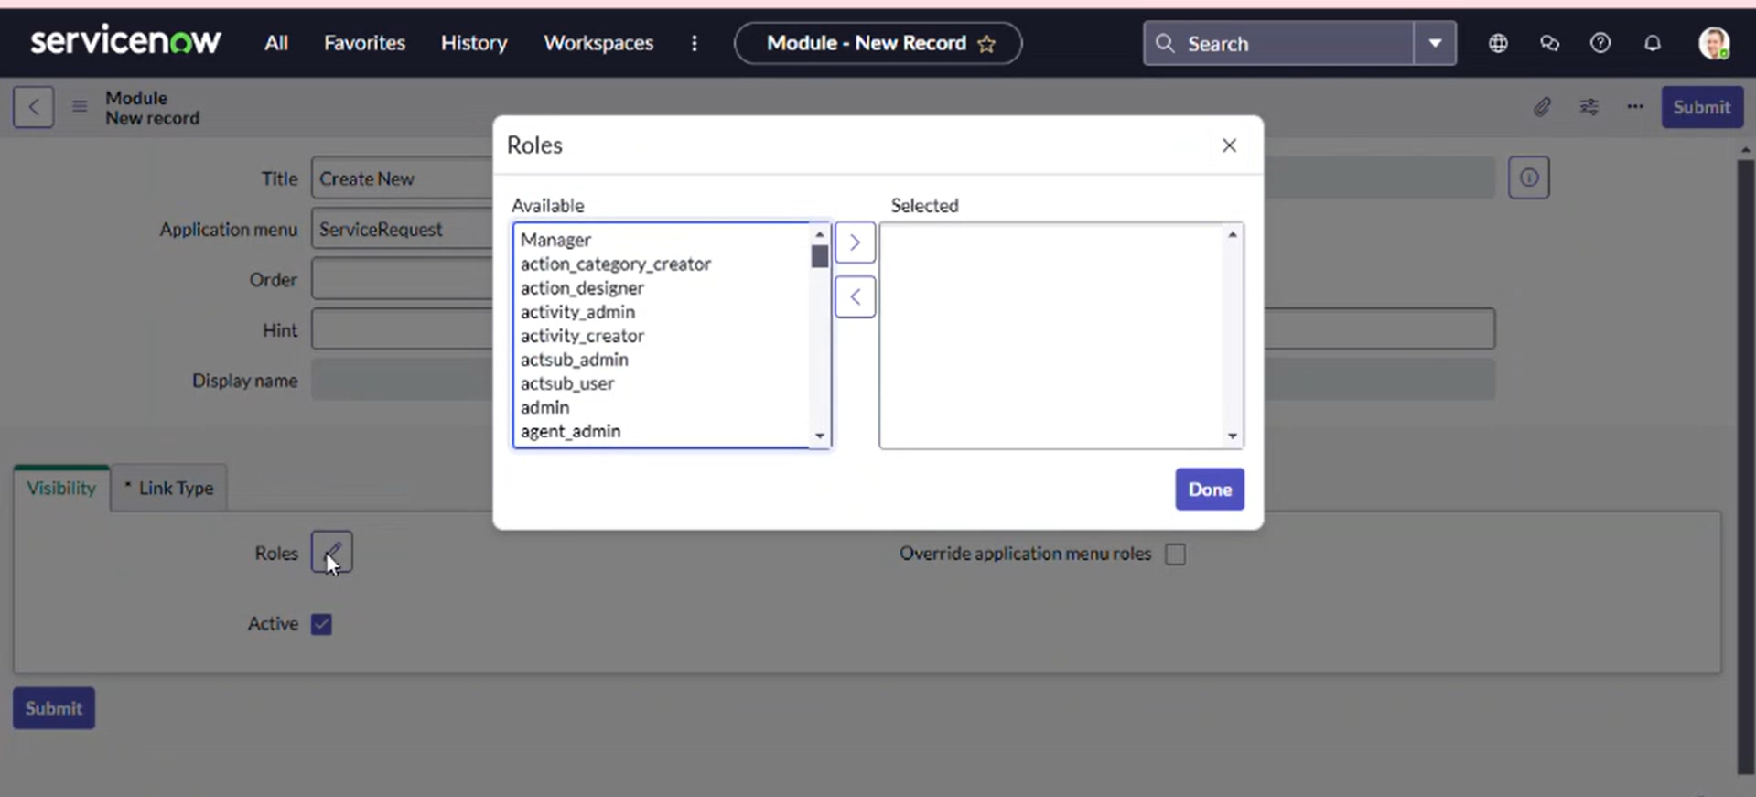

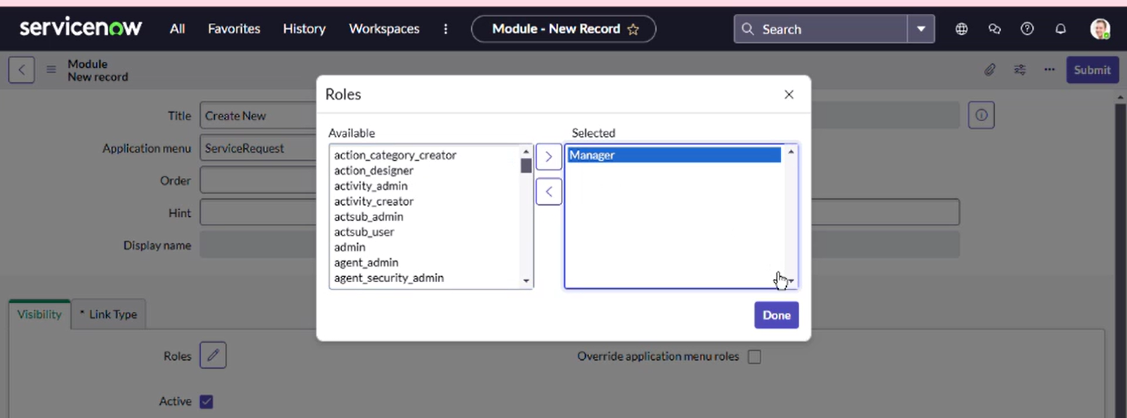

1. In Link Type, fill details

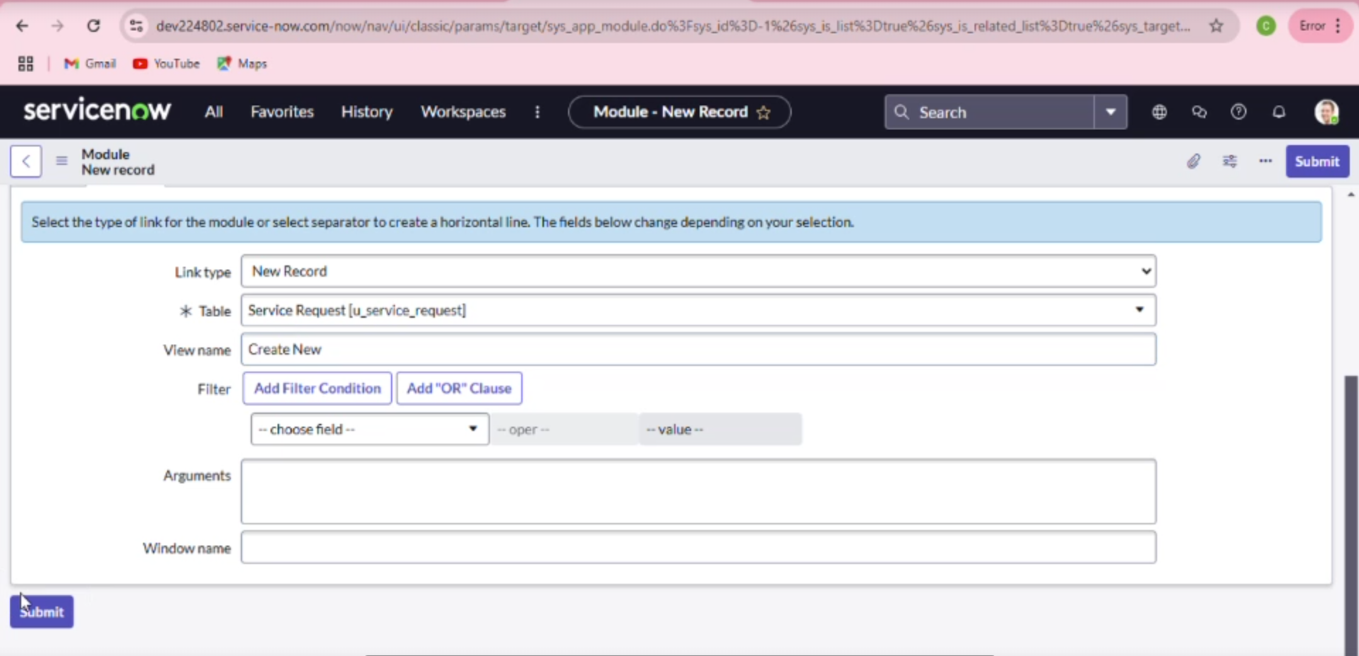

1. Click on Save.

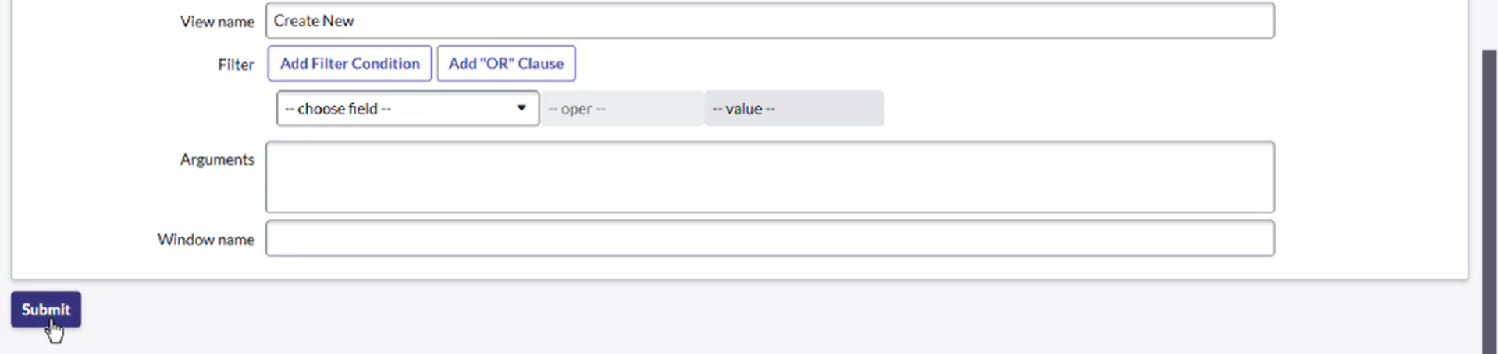

1. Now under Modules. Click on New.

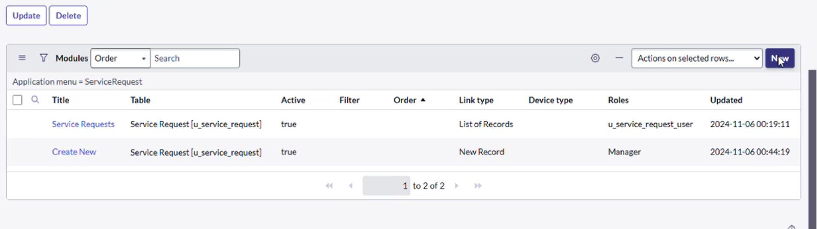

1. Enter the details as: Title : All

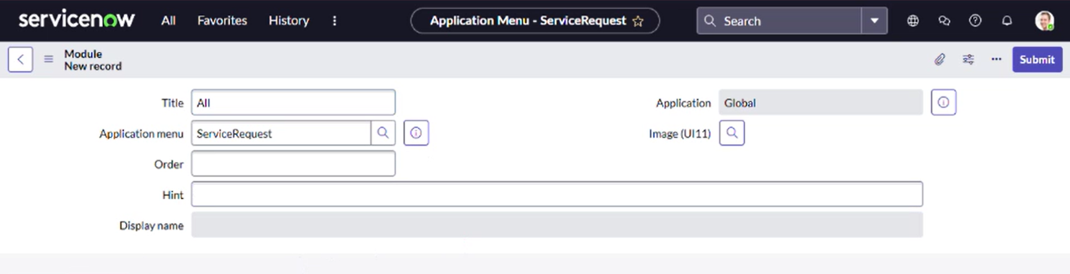

1. Under Visibility >> Select roles and select the role you want to assign.

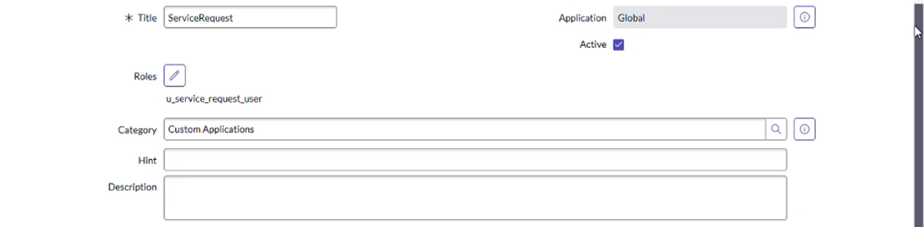

1. In Link Type, fill details
2. Click on Save.

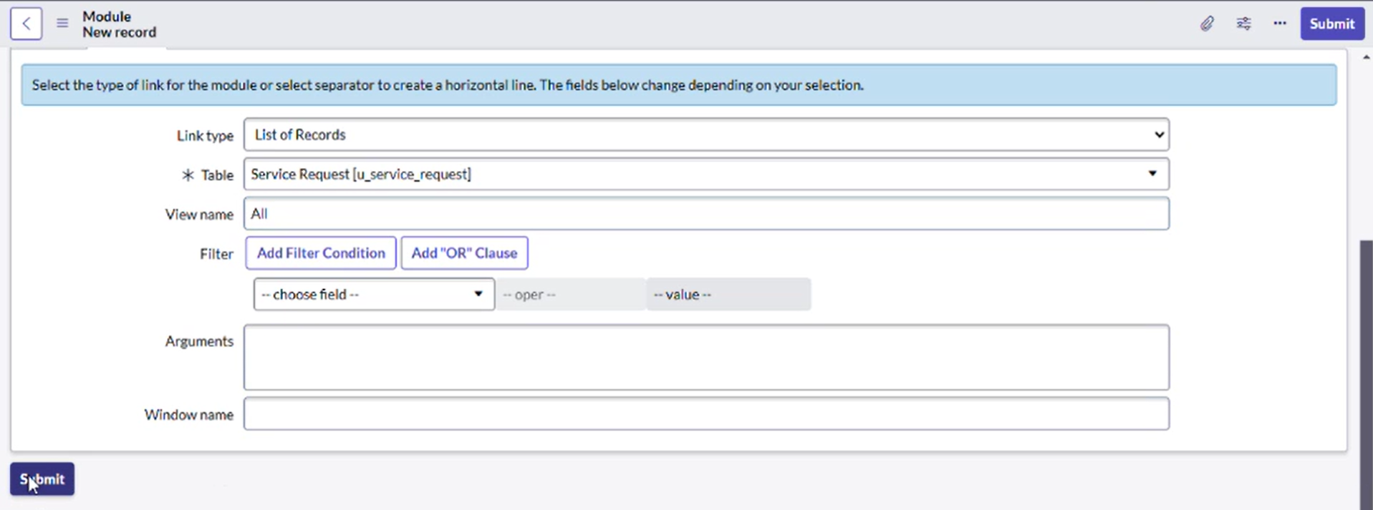

1. After that the Modules would look like below.

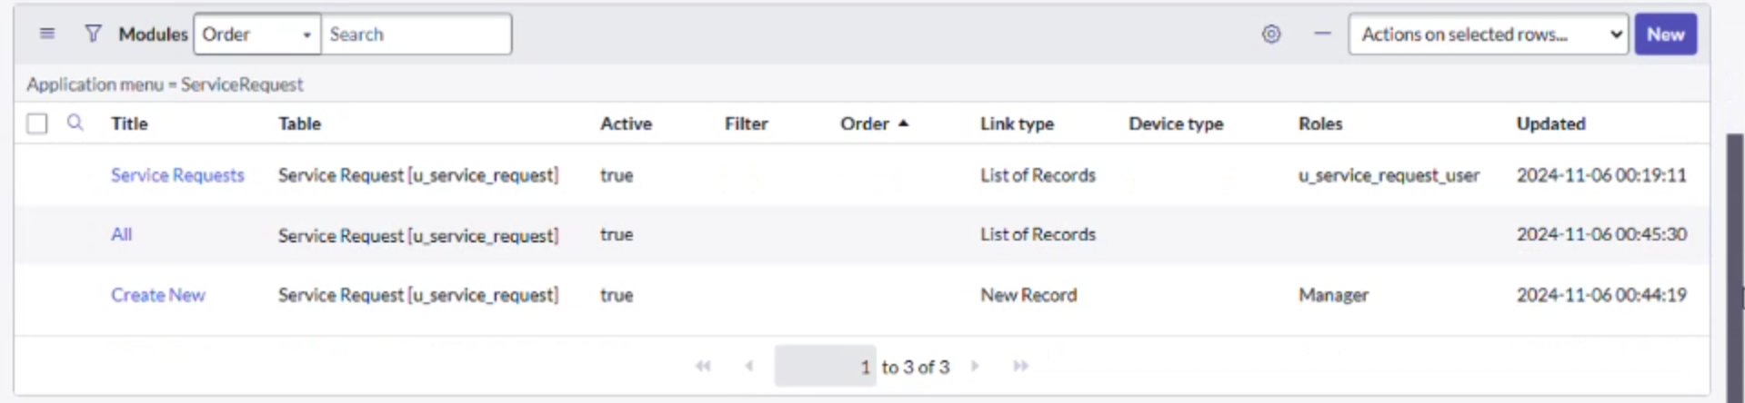

1. Click on save

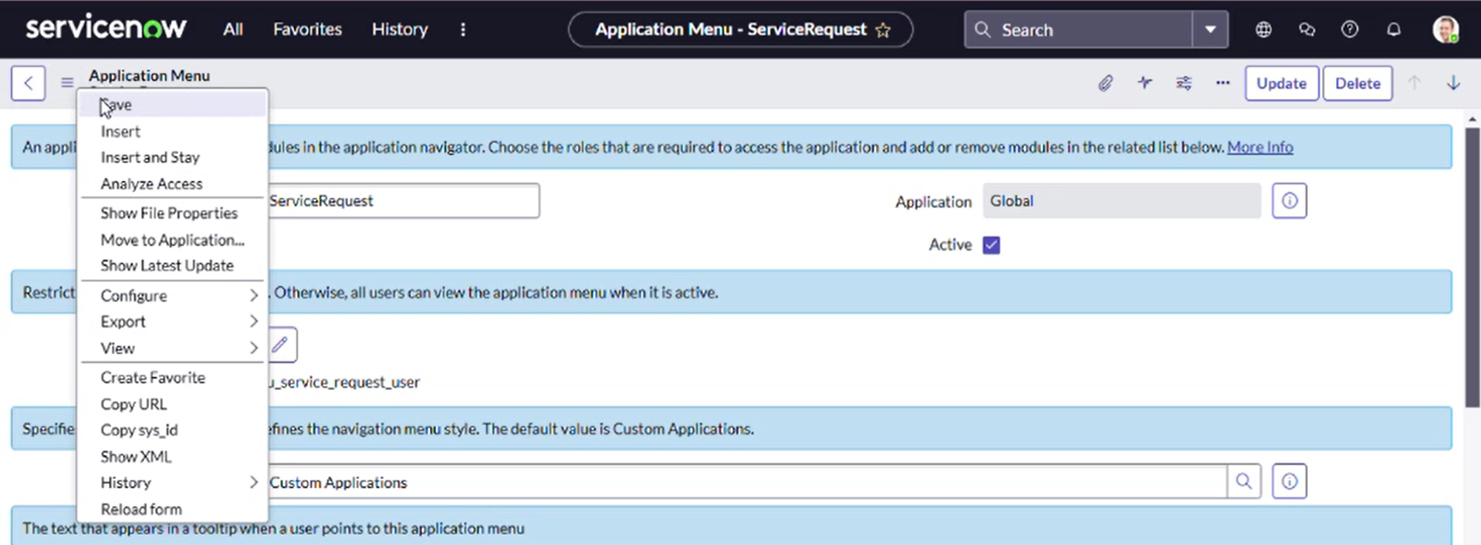

# 5. Testing and Validation

## Role-Based Access Control (RBAC):

## Test Scenario: Ensure that users with different roles (e.g., Admin, User, Approver) can access only the features or data they are authorized for.

## Unit Test Steps:

## Simulate users with different roles.

## Test that they can access or modify only the records or fields they are authorized to interact with.

## Assert that restricted roles cannot perform privileged actions.

## Features (SSO, MFA):

## Test Scenario: Verify that Single Sign-On (SSO) and Multi-Factor Authentication (MFA) integrations are functioning correctly, especially under edge cases like incorrect login or MFA failure.

## Unit Test Steps:

## Simulate user login with valid and invalid SSO credentials.

## Test MFA prompts and validate that users are required to authenticate with additional factors.

## Assert that unauthorized users cannot bypass security checks.

## Business Rules & Script Includes:

## Test Scenario: Test specific business rules and Script Includes that automate logic (e.g., setting access permissions, user role assignment, or data validation).

## Unit Test Steps:

## Write unit tests that simulate various data states and conditions for business rules or Script Includes.

## Validate that expected behaviors occur, such as record creation or data updates.

## Assert that logic performs correctly under different conditions (e.g., when a field is empty or when specific conditions are met).

## Data Integrity & Workflow Validations:

## Test Scenario: Ensure that workflows and scripts behave as expected when creating or modifying records.

## Unit Test Steps:

## Simulate the creation of incidents, tasks, or other records.

## Validate that workflows trigger as expected and that the correct fields are populated.

## Assert that the correct users and roles are assigned to tasks and records.

* + .

## 6. Key Scenarios Addressed by ServiceNow in the Implementation Project

**1. Role-Based Access Control (RBAC)**

Scenario: A user with different roles (Admin, IT Support, Regular User, etc.) needs to access different sets of records and functionalities.

How ServiceNow Addresses It:

RBAC is implemented to ensure that each user can only access the data and features that are relevant to their role.

Use Case: An IT Support staff member can view and manage incidents, while a Regular User can only view and create incident records but cannot modify them.

ServiceNow ensures that different roles receive tailored access to applications, modules, and records based on their specific permissions.

**2. Personalized Dashboards and Widgets**

Scenario: Users need dashboards that display only relevant data, such as incidents, approvals, or reports, based on their roles and preferences.

How ServiceNow Addresses It:

Personalized Dashboards are created for each user role (e.g., Service Desk agents see incident queues, Managers see performance metrics).

Widgets dynamically display information based on the user’s role and context.

Use Case: A service desk agent sees a "My Open Incidents" widget, while a manager sees performance metrics related to incident resolution times.

ServiceNow’s Service Portal and Self-Service Portal provide personalized user interfaces, ensuring that each user accesses only relevant information.

**3. Single Sign-On (SSO) and Multi-Factor Authentication (MFA)**

Scenario: A user needs secure and seamless access to ServiceNow without needing to remember multiple credentials, while ensuring data protection through MFA.

How ServiceNow Addresses It:

SSO integration allows users to access ServiceNow using their enterprise credentials, providing a frictionless login experience.

MFA ensures that users can only access their accounts after verifying their identity through a second factor, enhancing security.

Use Case: An employee logs into ServiceNow via their corporate SSO provider (e.g., Active Directory) and is prompted for MFA (e.g., a code sent to their phone) for added security.

ServiceNow’s SSO and MFA integration ensures seamless access and security compliance.

**4. Adaptive Onboarding and Guided Tours**

Scenario: A new user, or a user switching roles, requires an onboarding experience tailored to their role, guiding them through necessary features.

How ServiceNow Addresses It:

Adaptive Onboarding offers personalized tours and guidance to help users get familiar with the system based on their role.

Use Case: A new IT Support agent is guided through the steps to handle incidents, change requests, and manage knowledge articles, while a new manager is guided through performance dashboards and reporting tools.

ServiceNow provides Role-Based Onboarding to ensure a smoother learning curve for different user types.

**5. Dynamic UI Customization Based on User Preferences**

Users want to see specific fields, forms, or sections that are most relevant to their tasks, reducing cognitive load and improving usability.

# 7. Conclusion

**Summary of Achievements:**

The Tailored Application Access for Enhanced User Experience project in ServiceNow successfully delivered a secure, personalized, and efficient user experience by implementing role-based access controls (RBAC), adaptive onboarding, and dynamic user interfaces. By leveraging ServiceNow’s advanced features, the project ensured that each user received access to only the relevant modules, records, and workflows based on their roles, enhancing both usability and security. The integration of Single Sign-On (SSO) and Multi-Factor Authentication (MFA) streamlined authentication while ensuring robust security measures. Additionally, personalized dashboards, self-service capabilities, and knowledge management functionalities empowered users to efficiently resolve issues independently. The project also demonstrated scalability by supporting high volumes of users and requests without compromising performance. Ultimately, the implementation optimized operational efficiency, reduced manual intervention, and provided users with an intuitive, role-specific experience, aligning with organizational goals of enhancing productivity and user satisfaction.